ACCESS MANAGEMENT
Problems due to unassigned custom roles

As per the continuation of previous post, Here is the following image what we had done till now
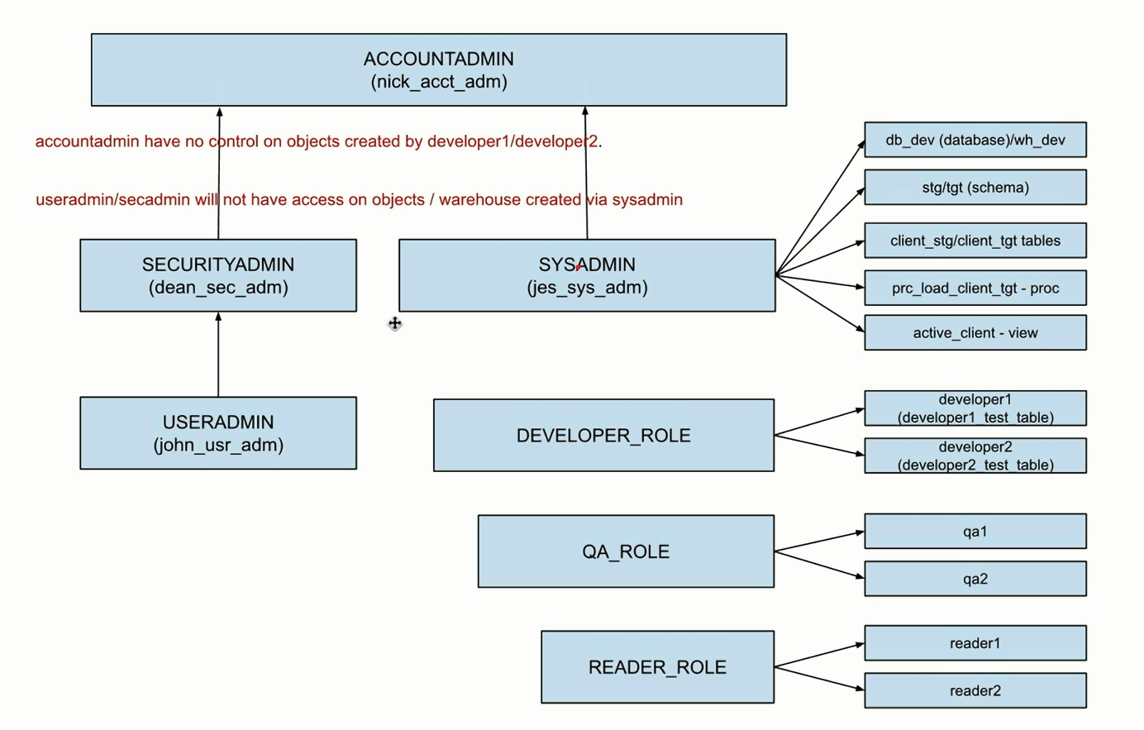
But main two fundamental problems in this structure are
1. Account admin have no control on objects created by developer1 & developer2 users
2. Security admin/user admin will not have access on objects/warehouses created via sysadmin

Hence, snowflake recommends that you create the hierarchy of the roles and then assign the top most role to the sysadmin to solve these two problems

Let’s see in practical
Problem1:
Login to account admin user i.e. nick_acct_adm
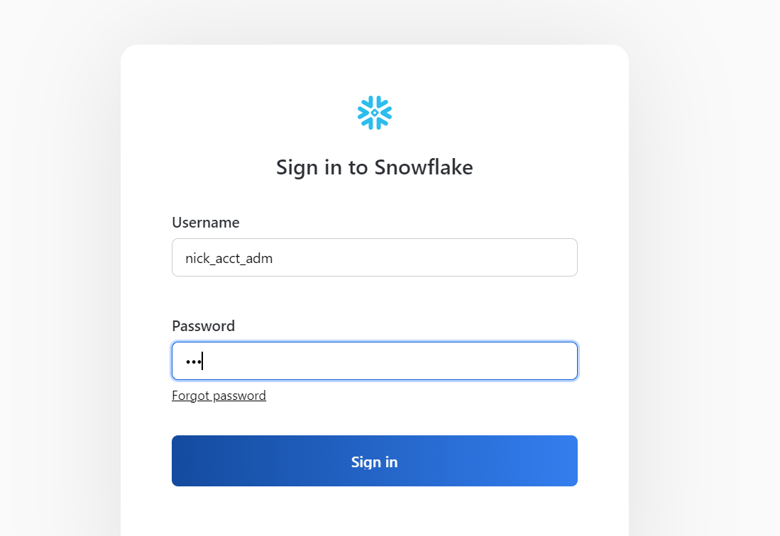
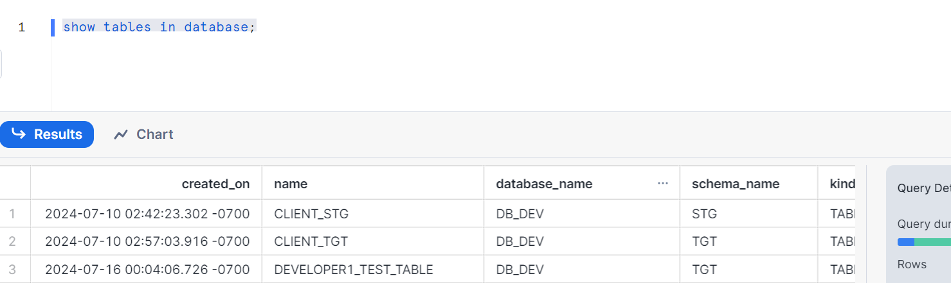
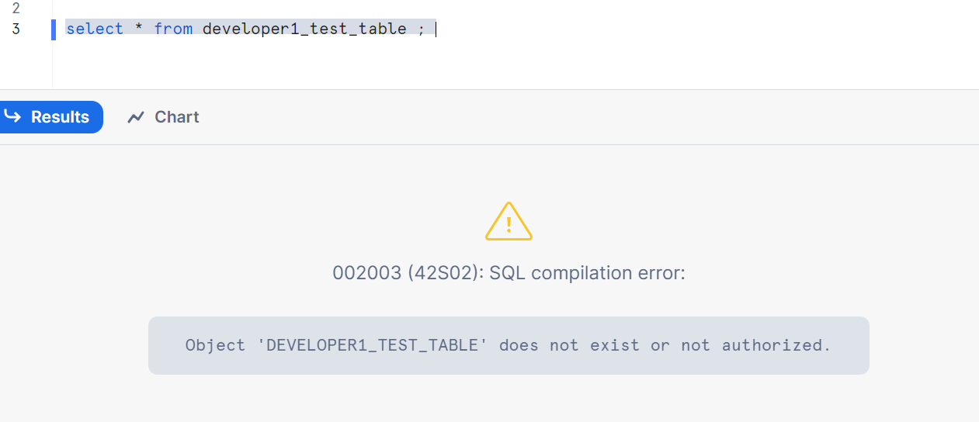
No access for the above user table
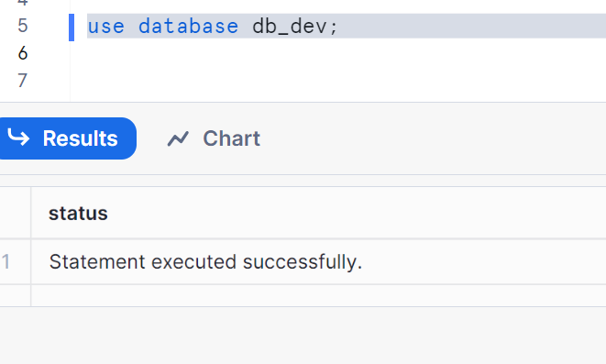
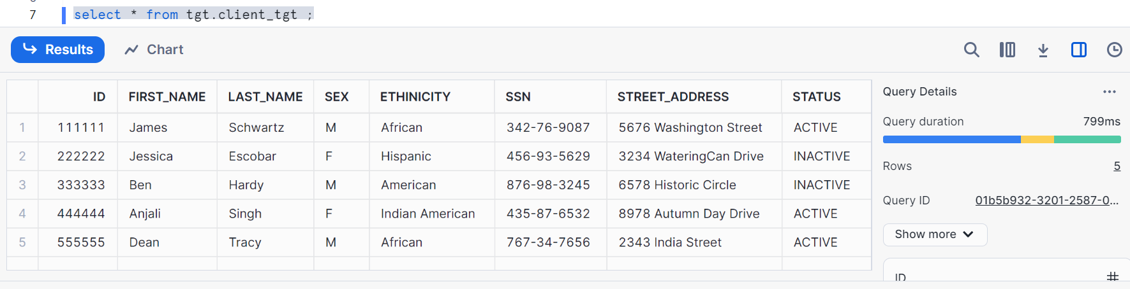
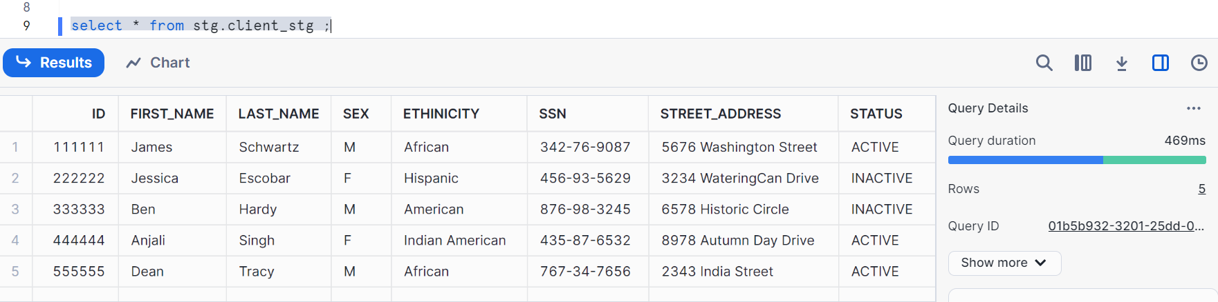
We are having access for above two tables since created via sysadmin user
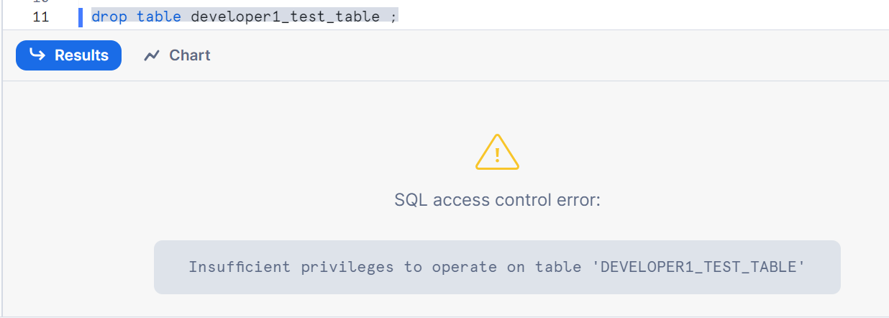
No access to drop
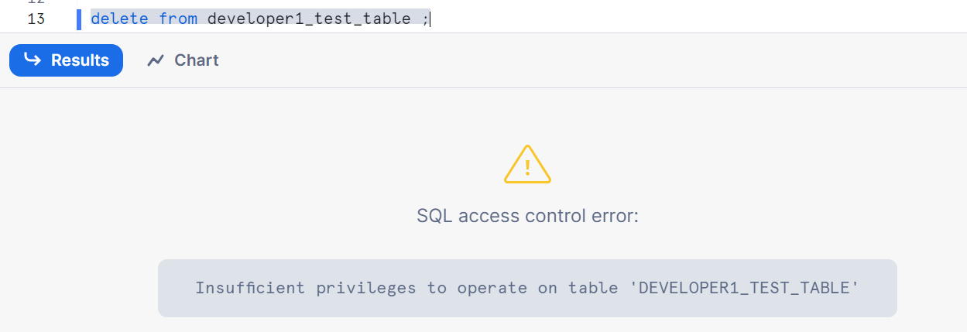

No access to delete
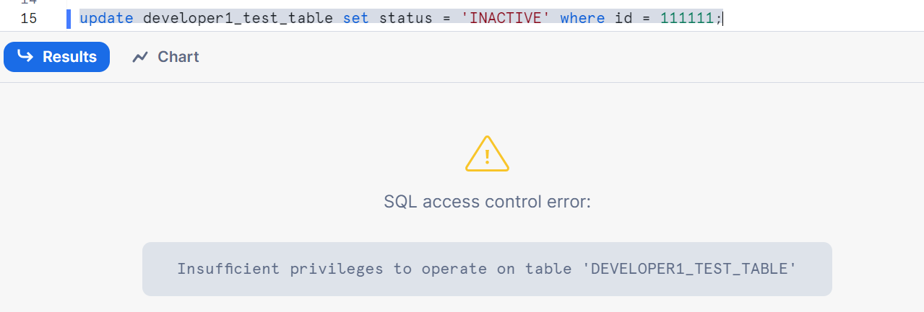
No access to update
Insufficient privileges, since the developer role is a custom role and not assigned to sysadmin

Now let’s check problem2
Problem2:
Log in to user admin
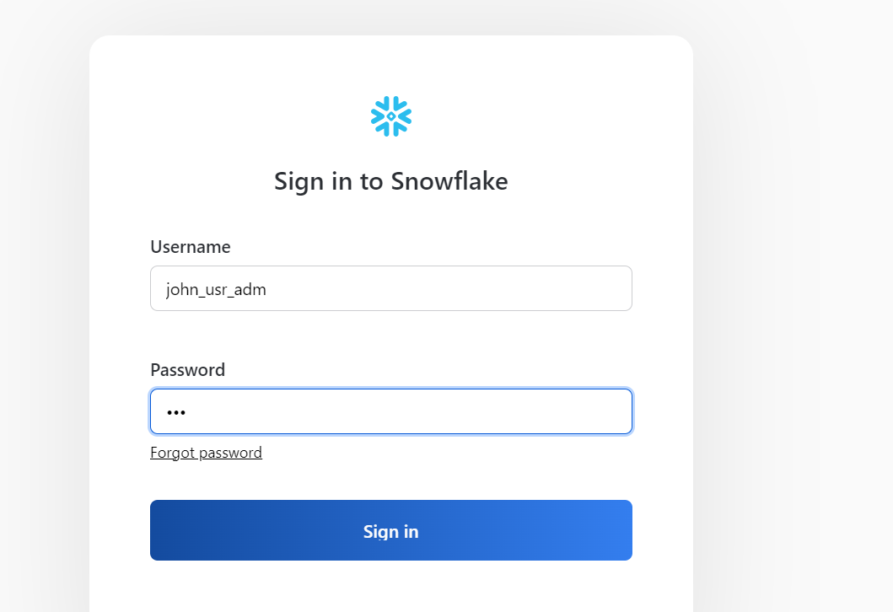
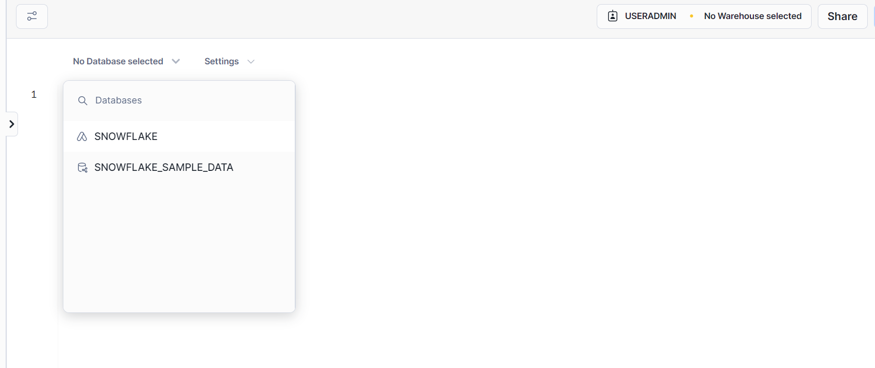
User admin role can’t access the sysadmin objects as we can see above that no database objects we created using sysadmin are coming in above image,
Let’s also check with queries
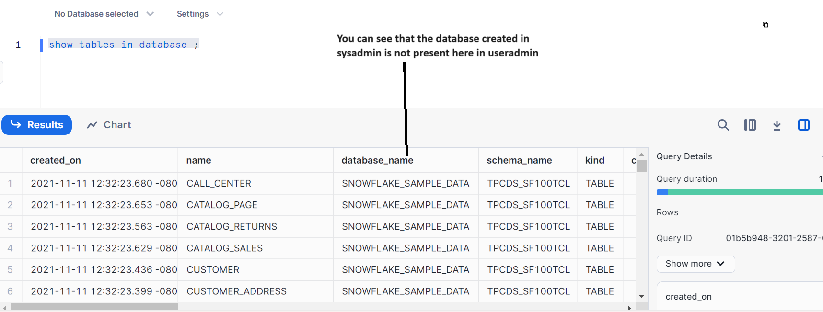
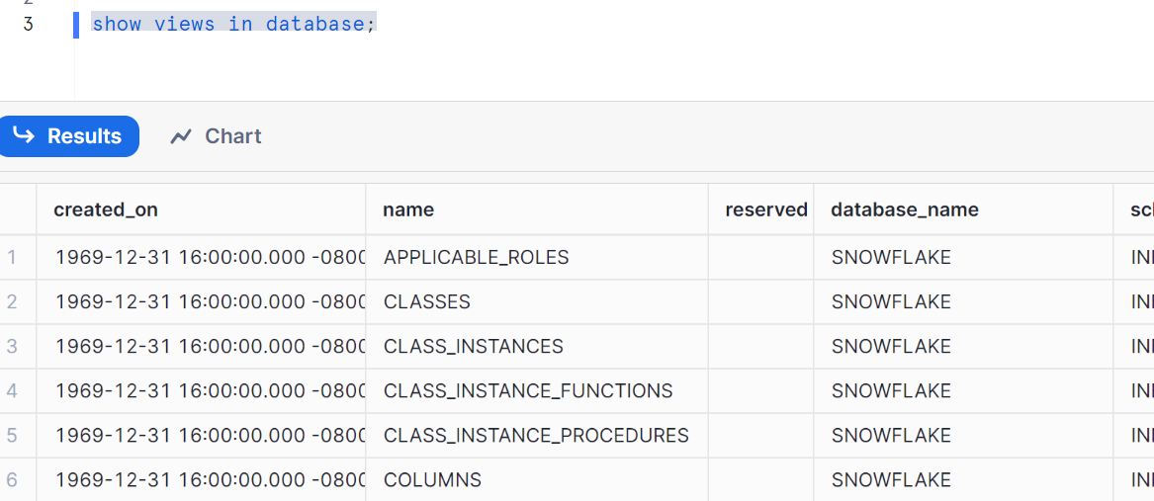
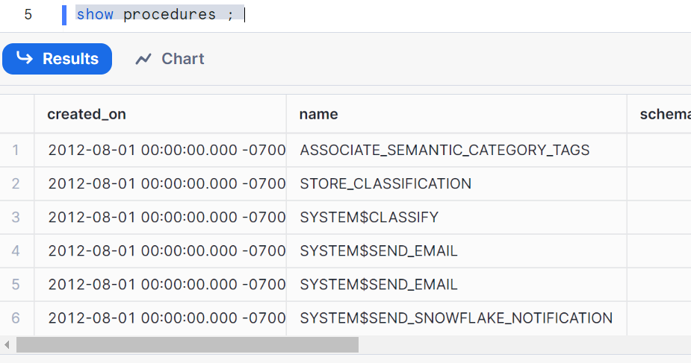
Can't access the warehouse / DB / Schemas created by sysadmin.
Sysadmin access is inherited to account admin. Hence the account admin was able to access the warehouse

Now, let’s login to security admin
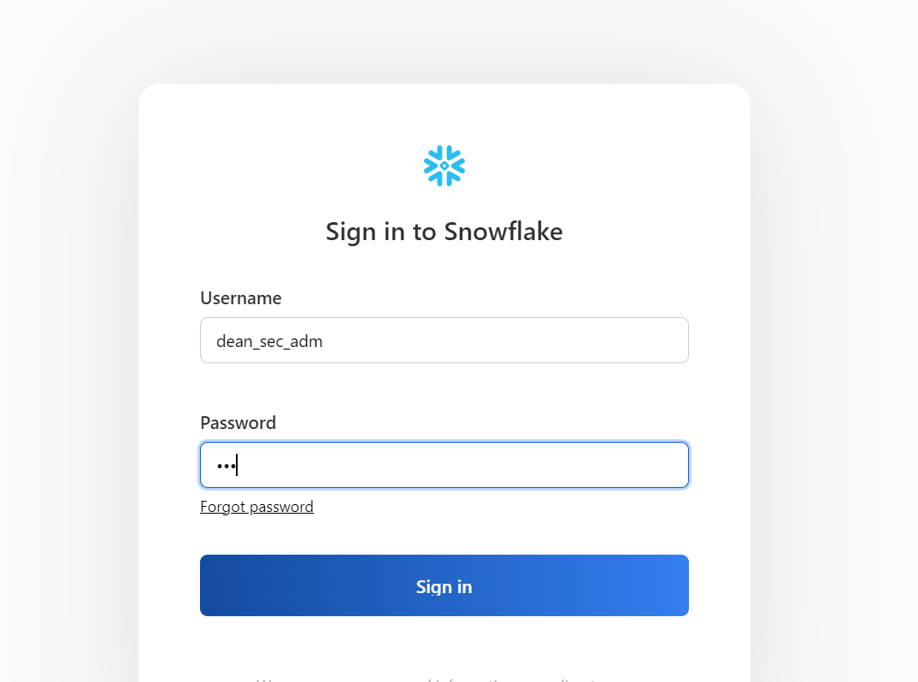
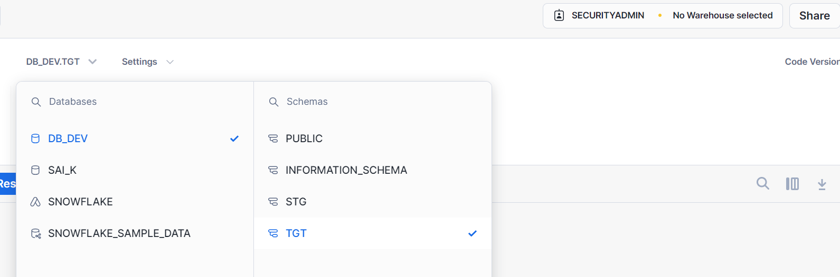
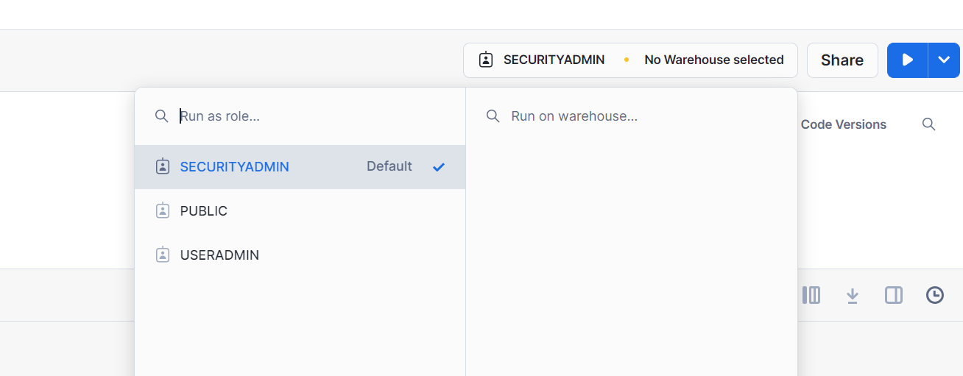
Let’s transfer the ownership of warehouse compute_wh to use it as we can see there is no warehouse to run the queries
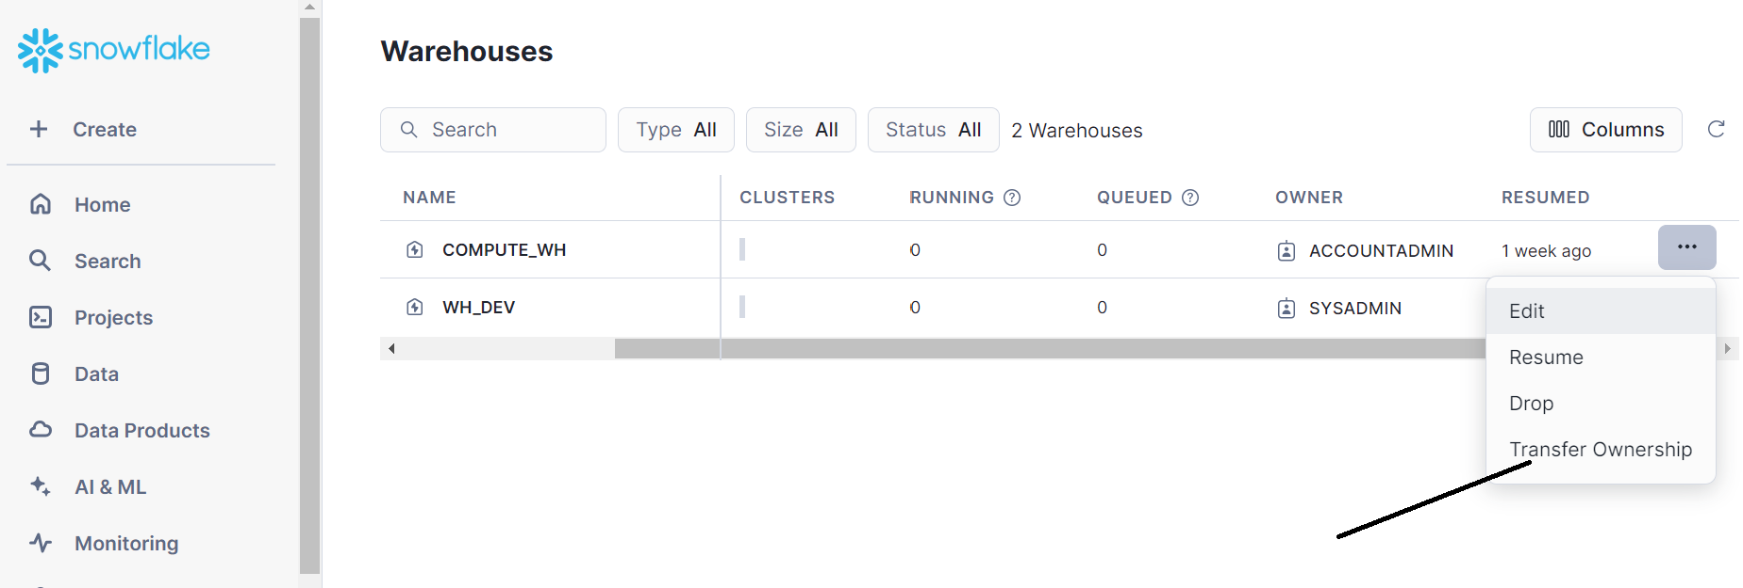
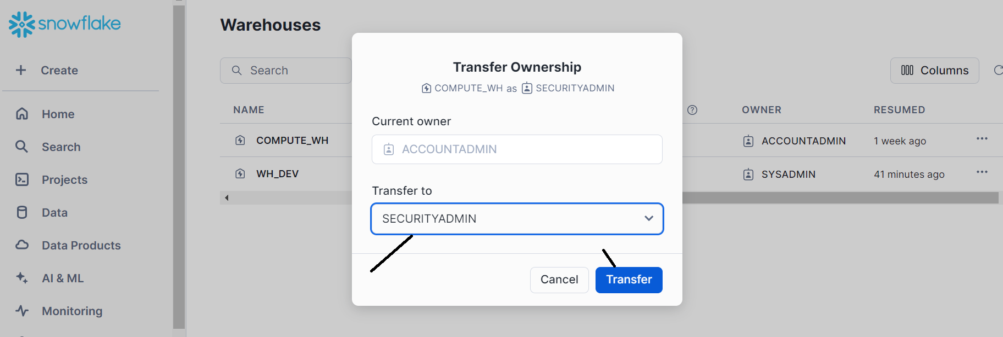

Go to worksheet and select the compute warehouse
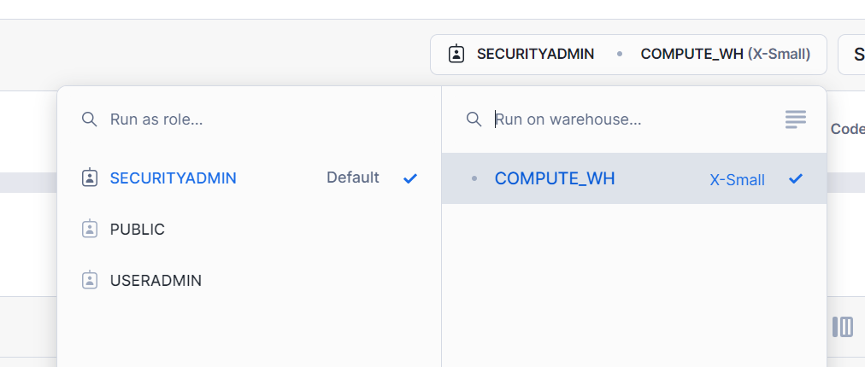

Run the queries to check
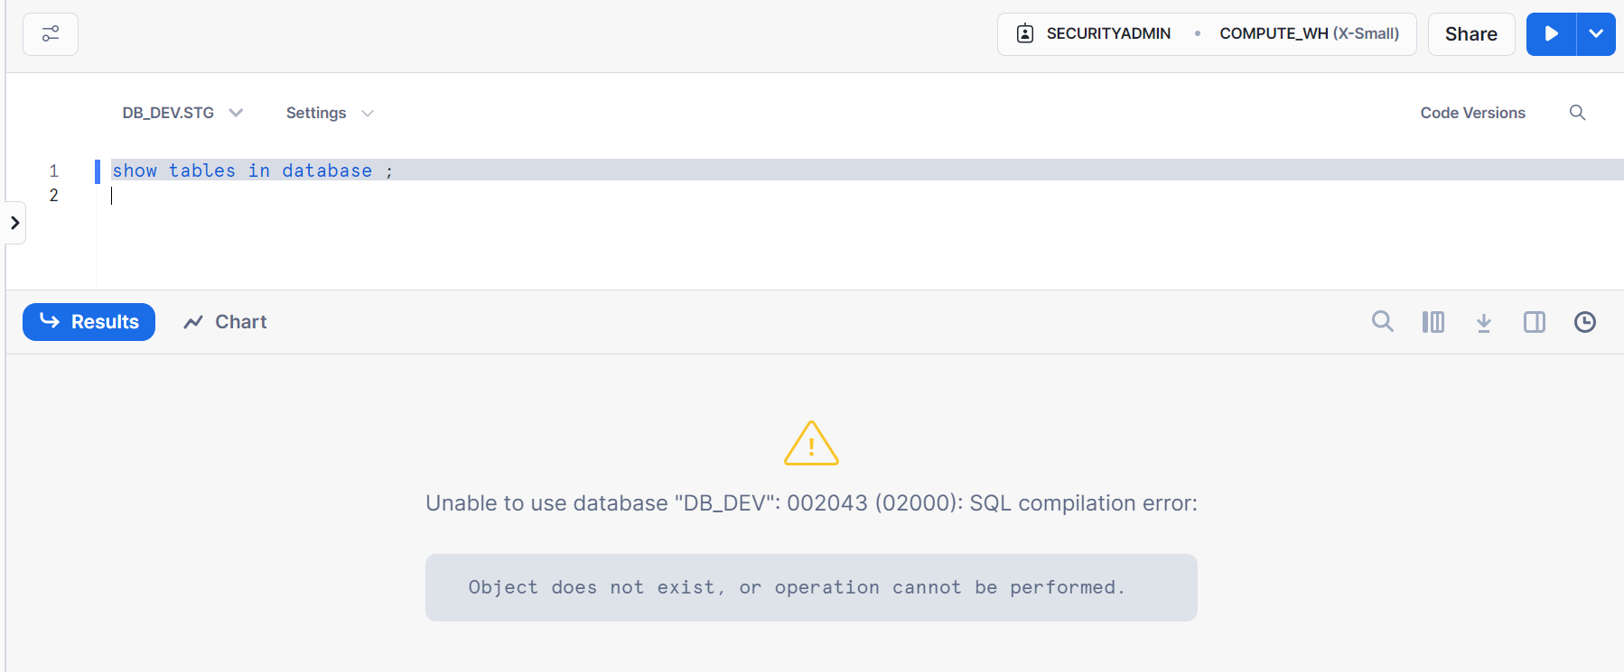
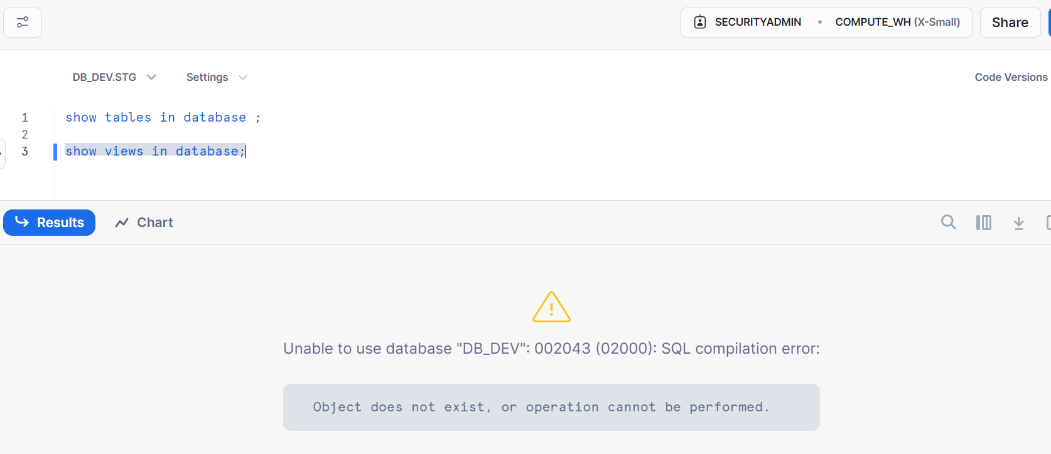
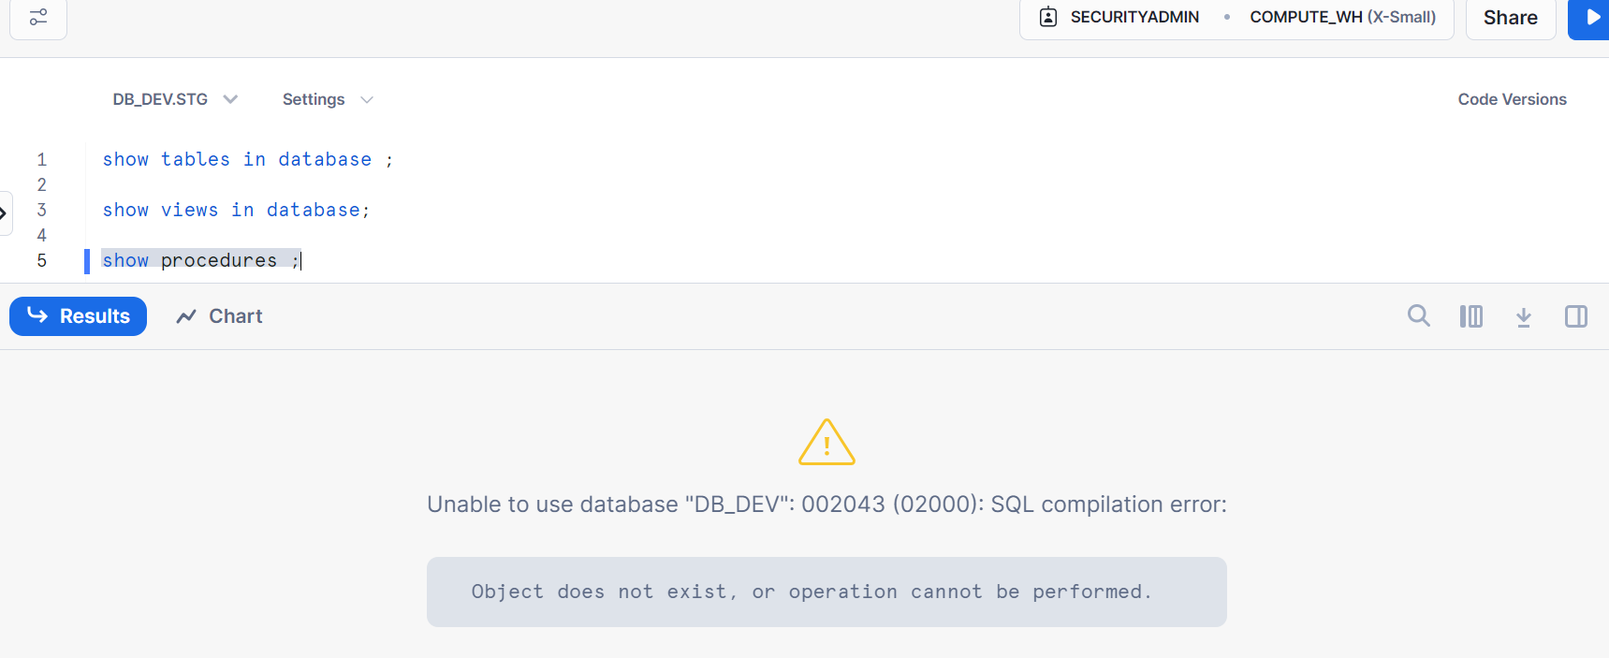
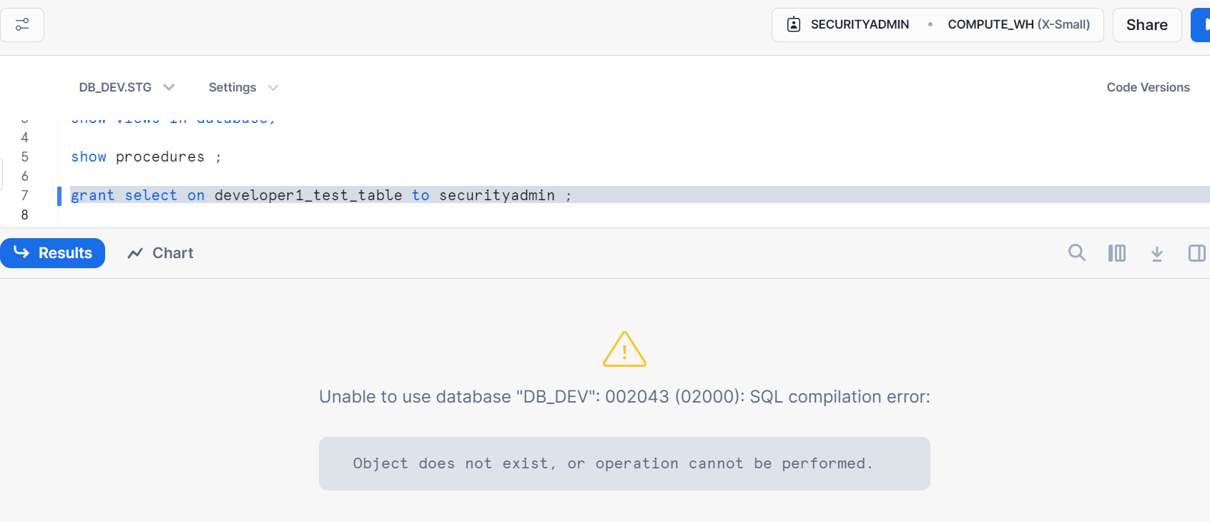
Therefore, No access to tables, views, procedures & grants created via sysadmin
Now, in this document you have seen the problems of hierarchy in the different roles with practical examples.
In next post, we will see the solutions of it like how to resolve it

Thanks

